**Nash Equilibrium**

Homework #3

1) *For the following two (one-shot) matrix games, determine the Nash equilibrium (pure and mixed) for both players.*

|  |  |  |
| --- | --- | --- |
|  | a | b |
| a | 4,4 | 0,3 |
| b | 3,0 | 2,2 |

|  |  |  |
| --- | --- | --- |
|  | c | d |
| a | 2,2 | 0,0 |
| b | 0,0 | 1,1 |

Game 2 Game 1

Let's identify a Nash equilibrium of the Game 1 for both, Orange and Blue, players. By going through each cell of the game and inspecting payoffs for both agents, we can conclude that both joint actions (a ; c) and (b ; d) are Nash equilibrium, since in both cases, neither player can benefit by unilaterally changing its strategy. Thus, (a ; c) and (b ; d) joint actions are pure strategy Nash equilibrium of the Game 1.

Mixed strategies for each player which make other player indifferent to choosing his/her actions, is called mixed strategy Nash equilibrium. Let’s find that mixed strategy for the Orange player

fo (p|”c”) = 2p + 0(1 - p)

fo (p|”d”) = 0p + 1(1 - p)

fo (p|”c”) = fo (p|”d”)

2p + 0(1 - p) = 0p + 1(1 - p)

2p = 1 – p

p =

Accordingly, if the Orange player chooses action “a” with a probability of and action “b” with a probability of then the Blue player will be indifferent to his/her choice. Likewise, if the Blue player chooses action “c” with a probability of and action “d” with a probability of then the Orange player will be indifferent to his/her choice.

Following the same inspections as for the Game 1, (a ; a) and (b ; b) joint actions are pure strategy Nash equilibrium of the Game 2. Let’s find the mixed strategy Nash equilibrium of the Game 2

fo (p|”a”) = 4p + 0(1 – p)

fo (p|”b”) = 3p + 2(1 – p)

4p + 0(1 – p) = 3p + 2(1 – p)

p =

So, if the Orange player chooses action “a” with a probability of and action “b” with a probability of then the Blue player will be indifferent to his/her choice.

fb (p|”a”) = 4p + 0(1 – p)

fb (p|”b”) = 3p + 2(1 – p)

fb (p|”a”) = fb (p|”b”)

p =

As the abovementioned results show, mixed strategy Nash equilibrium of the Game 2 is for both Orange and Blue players to play action “a” with a probability of and action “b” with a probability of .

2) *For the two one-shot matrix games above, compare and contrast the NE of the games with the Maximin strategies of the games.*

Referring to the previous homeworks, we can state that the Maximin strategy of the Game 1 for the Orange/Blue player is to play action “a” with a probability of p = and action “b” with a probability of p = . Consequently, Maximin strategy and Nash equilibrium of the Game 1 are the same for the Orange/Blue players. We can conclude that Maximin strategy and Nash equilibrium of pure coordination games are the same.

As for the Game 2, we can state that there doesn’t exist Maximin strategy of the Game 2, and Maximin value for both players is 2. However, we have figured out that the mixed strategy Nash equilibrium of the Game 2 for both players is to play action “a” with a probability of and action “b” with a probability of . Payoff for both players in the mixed strategy Nash equilibrium is . In conclusion, both players in the mixed strategy Nash equilibrium have higher payoffs than in Maximin strategy, therefore for this game mixed strategy Nash equilibrium is more profitable.

3) *Determine the Pareto optimal solutions in each of the above games.*

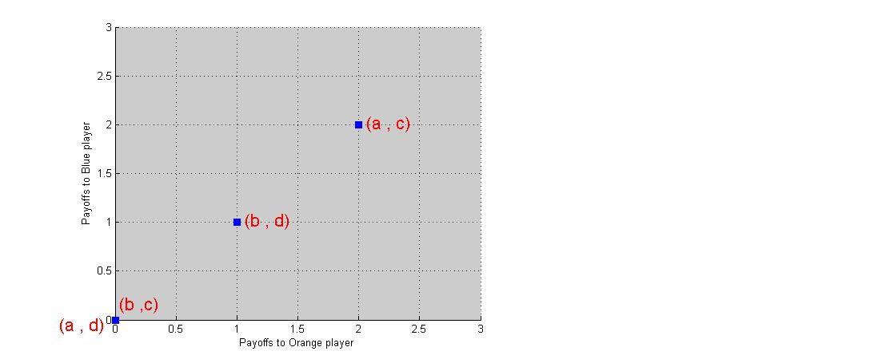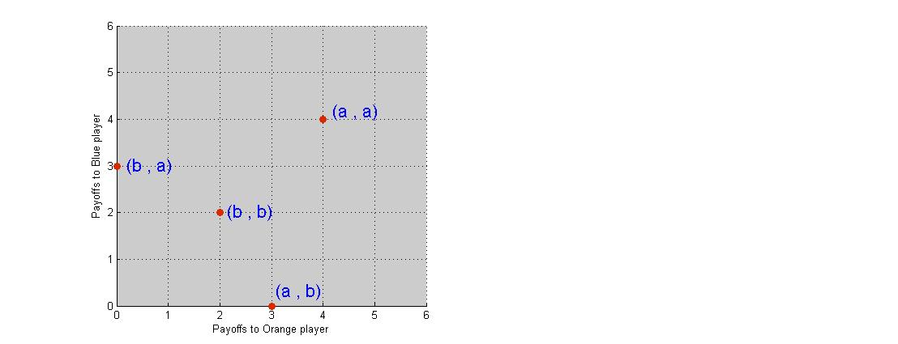

*Figure 1 Figure 2*

As the Figure 1 shows Pareto optimal solution in the Game 1 is the (a , c) joint action. The Figure 2 shows that Pareto optimal solution in the Game 2 is the (a, a) joint action.

4) *For the two one-shot matrix games above, state how you would play each game against an unknown associate if you were the row and column players, respectively. Briefly discuss why you would behave as you stated.*

Taking into consideration that these are one-shot games and the opponent is an unknown associate, I will definitely choose safest action which guarantees me the best payoff, in other words, I will play risk-averse.

Game 1: if I were the Orange player, I would choose action “a”, because it guarantees me a payoff of either 2 or 0, unlike the action “b” which does either 1 or 0. Whereas, being the Blue player I would choose the action “c”.

Game 2: If I were the Orange/Blue player I would choose action “b”, because in the worst case I will get a payoff of 2, unlike the action “a” when the worst I can get is 0.